**End up Navigation :**

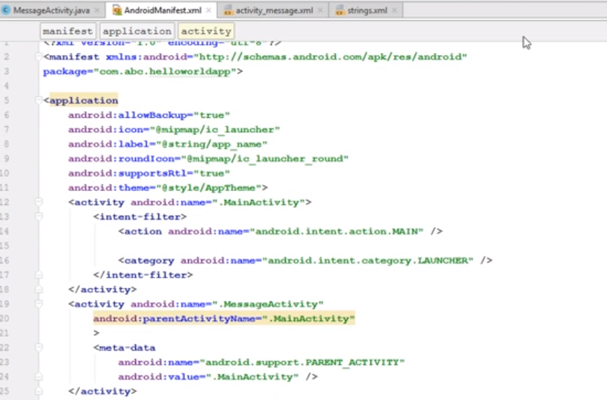

**Fragments :**

Create main file

And two fragment files then call those fragments in the main file :

*<?***xml version="1.0" encoding="utf-8"***?>*<**LinearLayout xmlns:android="http://schemas.android.com/apk/res/android"  
 xmlns:tools="http://schemas.android.com/tools"  
 android:layout_width="match_parent"  
 android:layout_height="match_parent"  
 android:paddingBottom="@dimen/activity_vertical_margin"  
 android:paddingLeft="@dimen/activity_horizontal_margin"  
 android:orientation="vertical"  
 android:paddingRight="@dimen/activity_horizontal_margin"  
 android:paddingTop="@dimen/activity_vertical_margin"  
 tools:context="com.example.ice_27.channel2.MainActivity"**>  
  
 <**fragment  
 android:layout_width="match_parent"  
 android:layout_height="0dp"  
 android:id="@+id/headline_fragment"  
 android:name="com.example.ice_27.channel2.headline_fragment"  
  
 android:layout_weight="1"** ></**fragment**>  
<**fragment  
 android:layout_width="match_parent"  
 android:layout_height="0dp"  
 android:id="@+id/article_fragment"  
 android:layout_weight="1"  
 android:name="com.example.ice_27.channel2.article_fragment"** ></**fragment**>

For Both fragments :

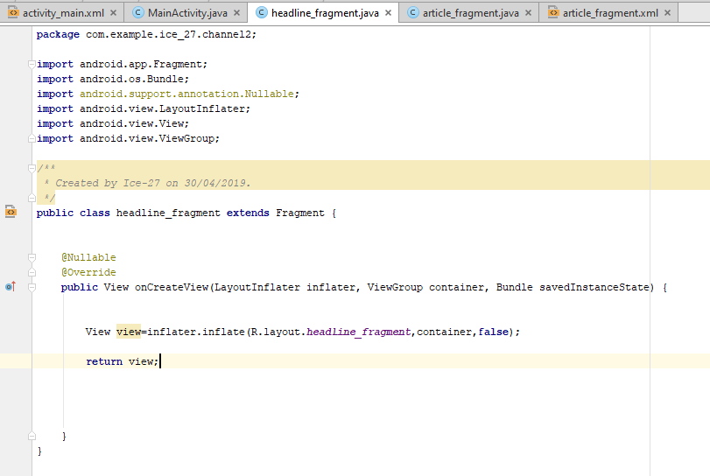

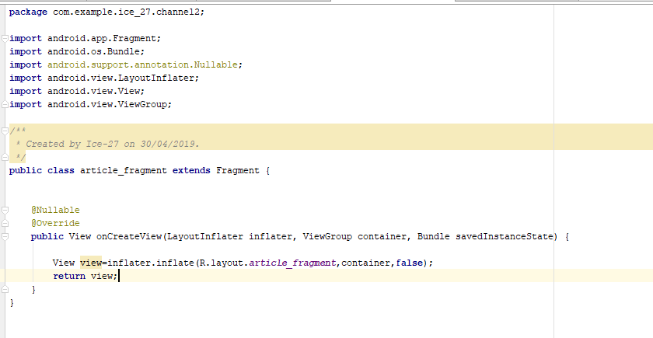

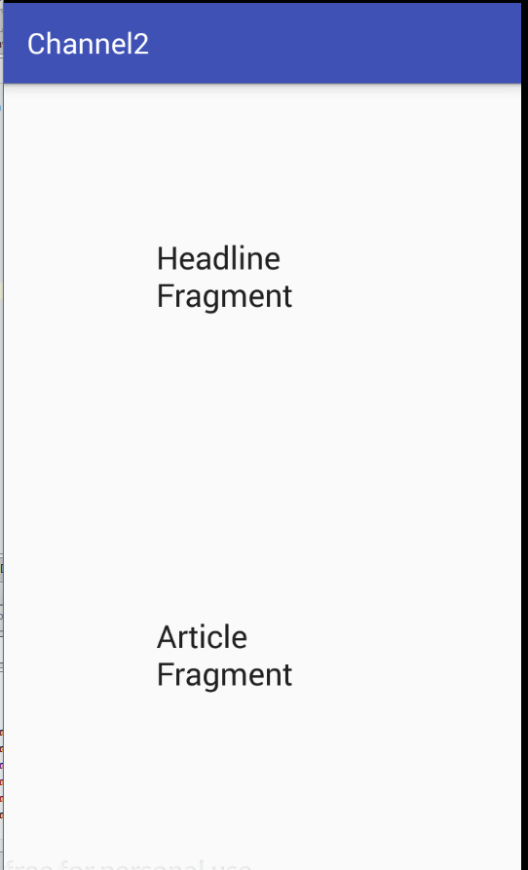

**Changing Fragments on runtime :**

Create Views :

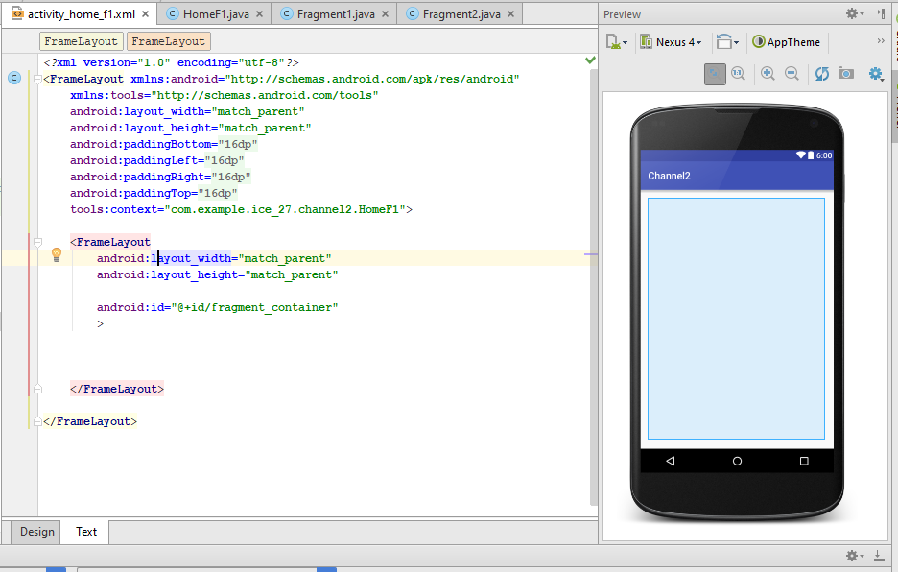

This is where fragments will change :

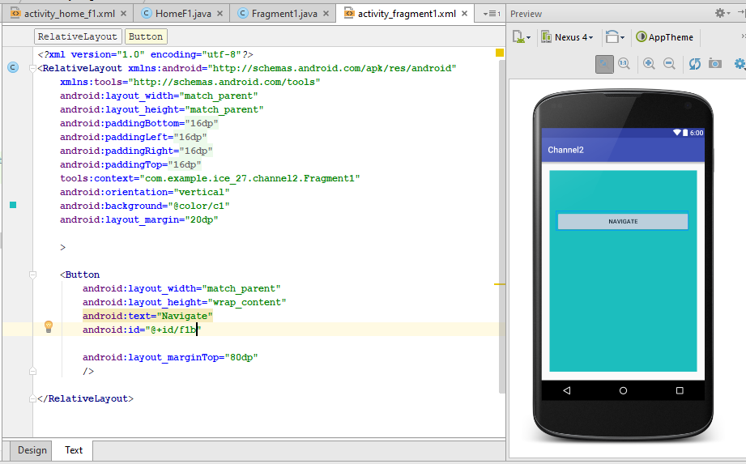

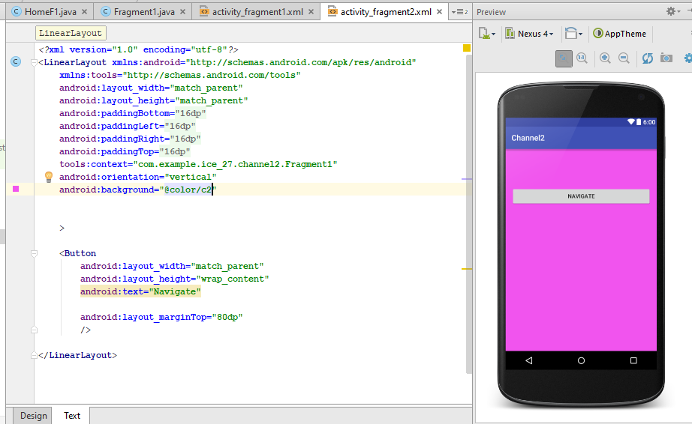

**Setting up fragment 1 in frame layout ;**

**package** com.example.ice_27.channel2;  
  
**import** android.support.v4.app.Fragment;  
**import** android.support.v4.app.FragmentManager;  
**import** android.support.v4.app.FragmentTransaction;  
**import** android.support.v7.app.AppCompatActivity;  
**import** android.os.Bundle;  
  
**public class** HomeF1 **extends** AppCompatActivity {  
  
  
 **public static** FragmentManager *fragmentManager*;  
  
 @Override  
 **protected void** onCreate(Bundle savedInstanceState) {  
 **super**.onCreate(savedInstanceState);  
 setContentView(R.layout.***activity_home_f1***);  
  
 *fragmentManager*=getSupportFragmentManager();  
  
 **if**(findViewById(R.id.***fragment_container***)!=**null**) {  
  
 **if**(savedInstanceState!=**null**){  
  
  
 **return**;  
 }  
  
 FragmentTransaction fragmentTransaction=*fragmentManager*.beginTransaction();  
  
 Fragment1 fa=**new** Fragment1();  
  
 fragmentTransaction.add(R.id.***fragment_container***, fa, **null**);  
  
 fragmentTransaction.commit();  
  
 }  
  
  
  
 }  
}

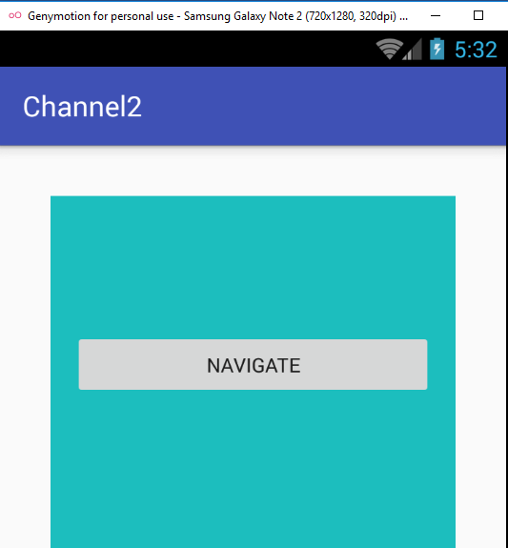

Setting up button to change fragment:

**package** com.example.ice_27.channel2;  
  
**import** android.support.v4.app.Fragment;  
**import** android.support.annotation.Nullable;  
**import** android.support.v7.app.AppCompatActivity;  
**import** android.os.Bundle;  
**import** android.view.LayoutInflater;  
**import** android.view.View;  
**import** android.view.ViewGroup;  
**import** android.widget.Button;  
  
**public class** Fragment1 **extends** Fragment {  
  
Button **b1**;  
 @Nullable  
 @Override  
 **public** View onCreateView(LayoutInflater inflater, ViewGroup container, Bundle savedInstanceState) {  
  
  
  
 View view=inflater.inflate(R.layout.***activity_fragment1***,container,**false**);  
  
 **b1**=(Button)view.findViewById(R.id.***f1b***);  
  
 **b1**.setOnClickListener(**new** View.OnClickListener() {  
 @Override  
 **public void** onClick(View v) {  
  
 HomeF1.*fragmentManager*.beginTransaction().replace(R.id.***fragment_container***,**new** Fragment2(),**null**).commit();  
 }  
 });  
  
 **return** view;  
  
  
  
 }  
}

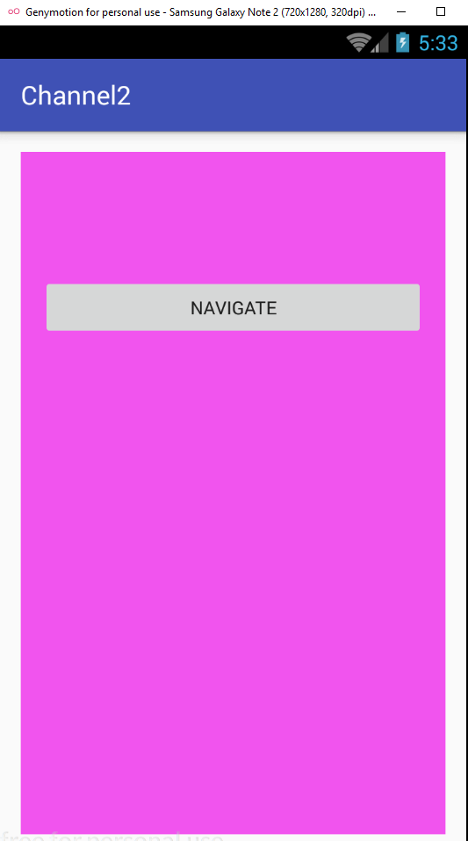

**Creating a notification :**

**package** com.example.ice_27.notifi;  
  
**import** android.app.Notification;  
**import** android.content.Context;  
**import** android.support.v4.app.NotificationManagerCompat;  
**import** android.support.v7.app.AppCompatActivity;  
**import** android.os.Bundle;  
**import** android.support.v7.app.NotificationCompat;  
**import** android.view.View;  
**import** android.widget.Button;  
  
  
**public class** Notifi **extends** AppCompatActivity {  
  
  
  
 **public final** String **CHANNEL_ID**=**"personal_notification"**;  
 **private final int NOTIFICATION_ID**=001;  
  
 Button **b1**;  
  
 @Override  
 **protected void** onCreate(Bundle savedInstanceState) {  
 **super**.onCreate(savedInstanceState);  
 setContentView(R.layout.***activity_notifi***);  
  
 **b1**=(Button)findViewById(R.id.***b1***);  
  
 **b1**.setOnClickListener(**new** View.OnClickListener() {  
 @Override  
 **public void** onClick(View v) {  
  
 NotificationCompat.Builder builder=**new** NotificationCompat.Builder(Notifi.**this**);  
 builder.setSmallIcon(R.drawable.***ic_power_settings_new_black_24dp***);  
 builder.setContentTitle(**"First Notification"**);  
 builder.setContentText(**"Hello world"**);  
  
 builder.setPriority(NotificationCompat.***PRIORITY_DEFAULT***);  
  
 NotificationManagerCompat notificationManagerCompat=NotificationManagerCompat.*from*(Notifi.**this**);  
  
 notificationManagerCompat.notify(**NOTIFICATION_ID**,builder.build());  
  
 }  
 });  
  
  
 }  
}

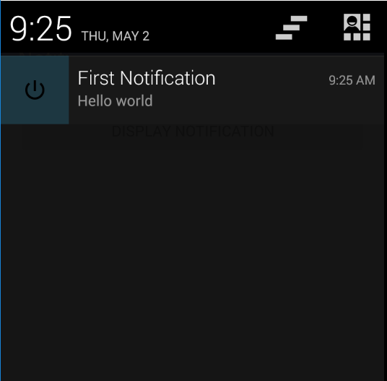

**Set action to notification :**

**package** com.example.ice_27.notifi;  
  
**import** android.app.Notification;  
**import** android.app.PendingIntent;  
**import** android.content.Context;  
**import** android.content.Intent;  
**import** android.support.v4.app.NotificationManagerCompat;  
**import** android.support.v7.app.AppCompatActivity;  
**import** android.os.Bundle;  
**import** android.support.v7.app.NotificationCompat;  
**import** android.view.View;  
**import** android.widget.Button;  
  
  
**public class** Notifi **extends** AppCompatActivity {  
  
  
  
 **public final** String **CHANNEL_ID**=**"personal_notification"**;  
 **private final int NOTIFICATION_ID**=001;  
  
 Button **b1**;  
  
 @Override  
 **protected void** onCreate(Bundle savedInstanceState) {  
 **super**.onCreate(savedInstanceState);  
 setContentView(R.layout.***activity_notifi***);  
  
 **b1**=(Button)findViewById(R.id.***b1***);  
  
 **b1**.setOnClickListener(**new** View.OnClickListener() {  
 @Override  
 **public void** onClick(View v) {  
  
  
 Intent it=**new** Intent(Notifi.**this**,screen2.**class**);  
  
 it.setFlags(Intent.***FLAG_ACTIVITY_NEW_TASK***|Intent.***FLAG_ACTIVITY_CLEAR_TASK***);  
  
 PendingIntent pit=PendingIntent.*getActivities*(Notifi.**this**,0, **new** Intent[]{it},PendingIntent.***FLAG_ONE_SHOT***);  
  
 NotificationCompat.Builder builder=**new** NotificationCompat.Builder(Notifi.**this**);  
 builder.setSmallIcon(R.drawable.***ic_power_settings_new_black_24dp***);  
 builder.setContentTitle(**"First Notification"**);  
 builder.setContentText(**"Hello world"**);  
 builder.setAutoCancel(**true**);  
  
 builder.setPriority(NotificationCompat.***PRIORITY_DEFAULT***);  
  
 NotificationManagerCompat notificationManagerCompat=NotificationManagerCompat.*from*(Notifi.**this**);  
  
 notificationManagerCompat.notify(**NOTIFICATION_ID**,builder.build());  
  
  
 builder.setContentIntent(pit);  
  
 }  
 });  
  
  
 }  
}